**Here are some examples of jugaad :-**

1. **A steel rod used to support the plant**

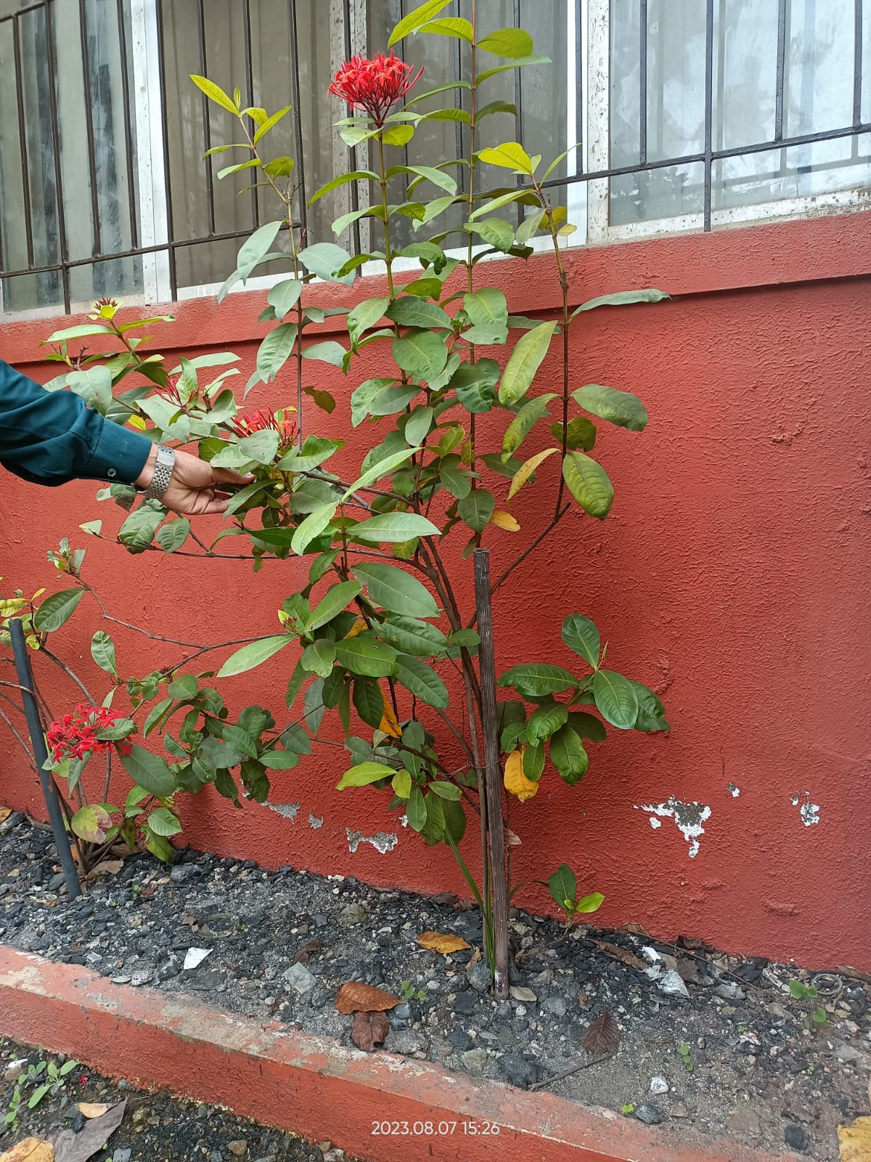

***Image Source:*** *PICT Pune Playground*

As plants develop and produce flowers, the added weight of the blossoms can sometimes cause the stems to bend or droop, altering the plant's overall appearance and potentially making them vulnerable to adverse weather conditions.When plants become weighed down by their flowers, their natural growth posture can be disrupted.

This image portrays a prime example of jugaad.In the image, a steel rod has been ingeniously repurposed to serve as a makeshift support for a growing plant, enabling it to reach greater heights.

**2)A metal sheet used as cricket stumps**

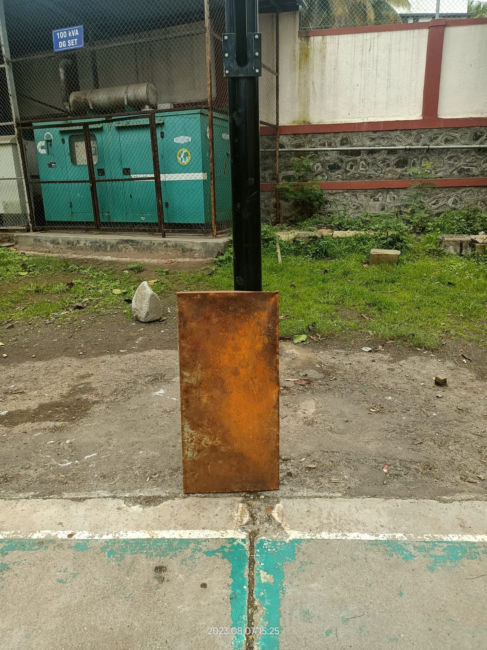

***Image Source:*** *PICT Pune Playground*

In the traditional game of cricket, stumps are typically made of wood and consist of three vertical posts that are driven into the ground to mark the wicket.

However, in this scenario, a metal sheet plate is repurposed to serve as the stumps, introducing an element of "jugaad" into the game.

**3)A water bottle is placed in between the plant**

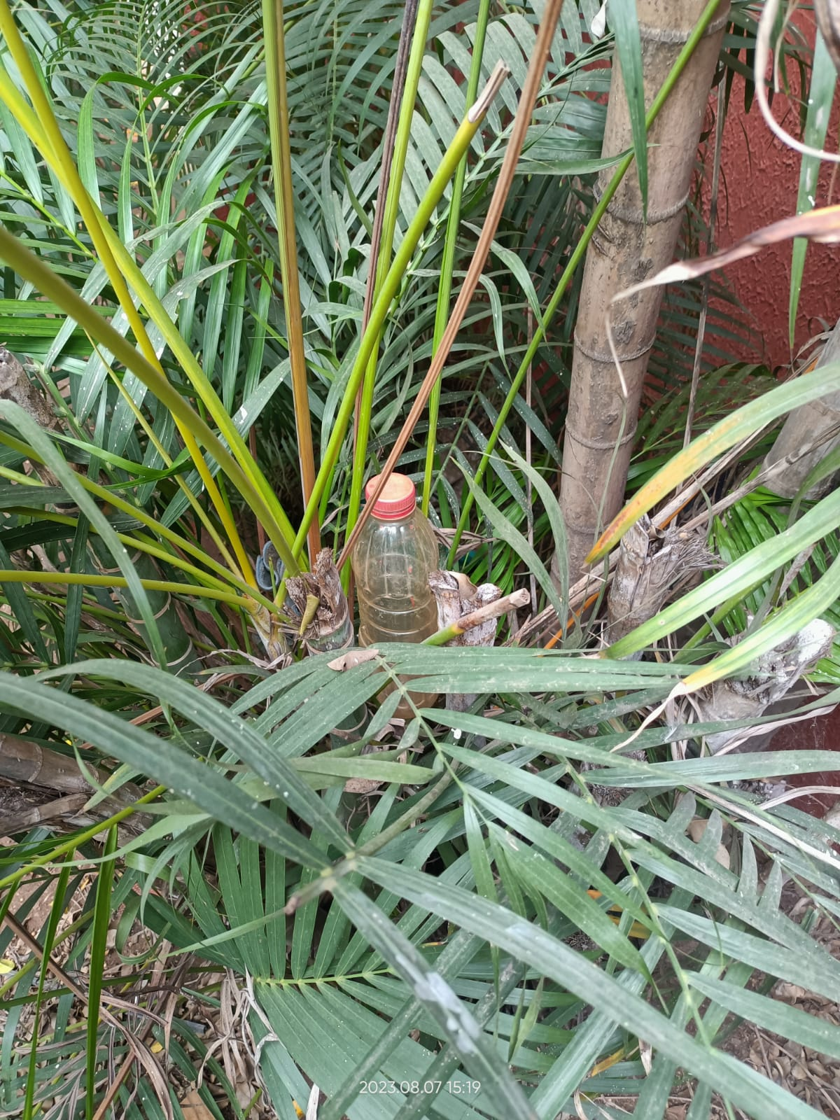

***Image Source:*** *PICT Pune A-1 Building Entrance*

Plants require water for their growth and nourishment, and ensuring that water reaches the roots effectively is essential.

This jugaad depicts that a water bottle is placed in between the plant’s branches so that the water reaches to the roots of the plant.The placement of a water bottle among the plant's branches serves as a clever mechanism to achieve this goal.

**4)A cardboard used as mudguard to avoid splatter from mud**

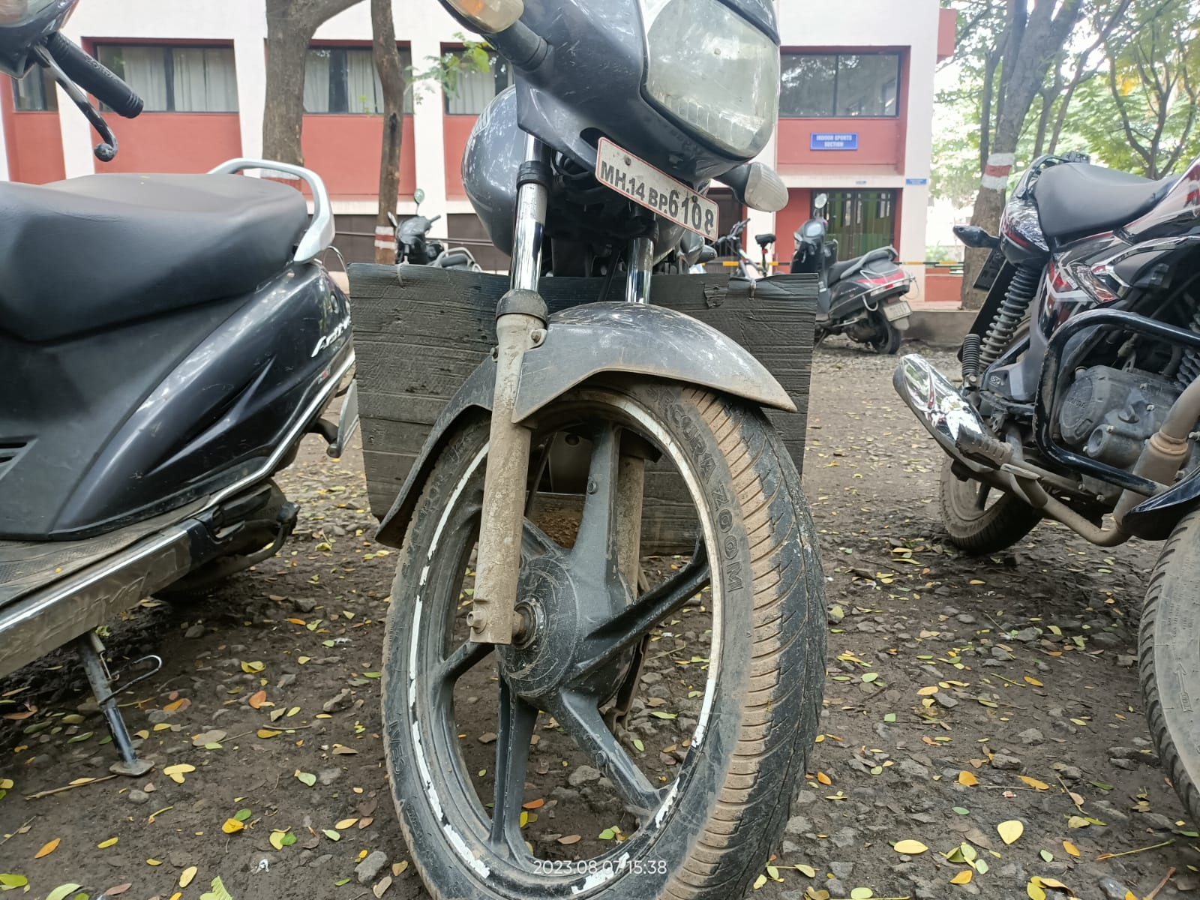

***Image Source:*** *PICT Pune Parking Area*

In situations where bikes move through muddy terrain, there's often a risk of mud and debris being flung onto surfaces, causing dirt and mess. A mudguard is a protective covering typically found on vehicles, bicycles, or machinery to shield them from mud, water, and other debris that can be kicked up by the wheels.

The use of cardboard as a mudguard is a practical and resourceful solution to mitigate this issue and can be termed into the category of jugaad.

**5) A part of dustpan is used for covering CCTVs**

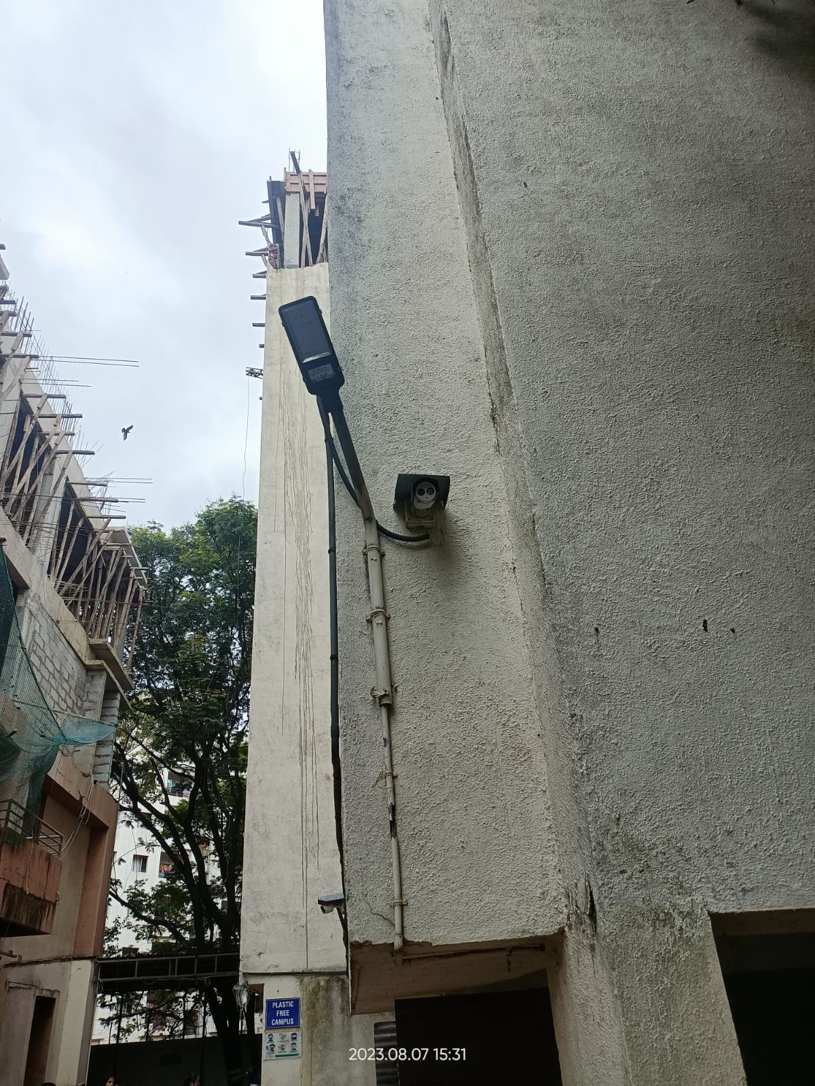

***Image Source:*** *PICT Pune Boys Hostel*

The plane part of the dustpan is used for covering CCTVs. These plane parts can be used as shields which are used for protecting the CCTVs from dust, rain and other kinds of precipitation.

**Here are some examples of jugaad from surroundings :-**

1. **A plastic bottle used as sprinkler**

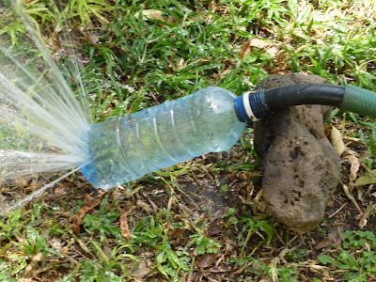

***Image Source:*** *Home Garden*

Sprinklers are commonly used for watering lawns, gardens, and other outdoor spaces. They distribute water in a spray-like pattern to ensure even coverage.

Instead of using regular/traditional sprinklers, a plastic bottle with pores is repurposed to serve as a simple sprinkler alternative.

1. **A tyre is used as swing**

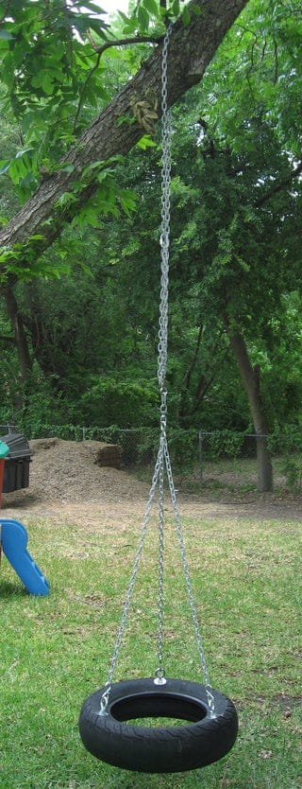

***Image Source:*** *Park, Bhosari*

Traditional swings are usually purpose-built structures. This scenario involves a classic example of using a repurposed item in a creative way – in this case, tying a tire to a tree to create a swing. This approach demonstrates resourcefulness and innovation, as well as a touch of nostalgia, often associated with playful childhood memories. Using a tire as a swing has several advantages. It's a simple and cost-effective way to create a recreational activity in an outdoor setting.

**Here are some examples of jugaad from Internet :-**

1. **Using Ice Cream Sticks as Home Decorator :-**

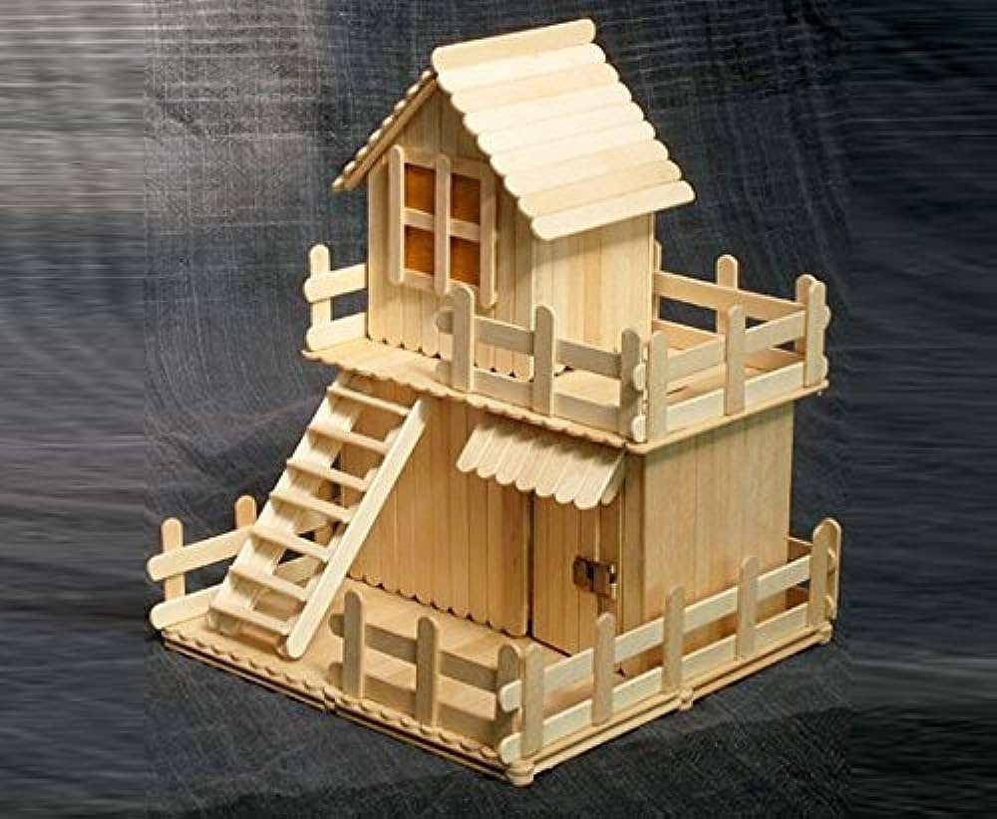

Ice cream sticks, originally intended for holding ice cream, have found a new purpose as a "jugaad" solution for creative and eco-friendly home decor, showcasing resourcefulness and inventive repurposing.

1. **Using Bottle for Holding Mosquito Coils :-**

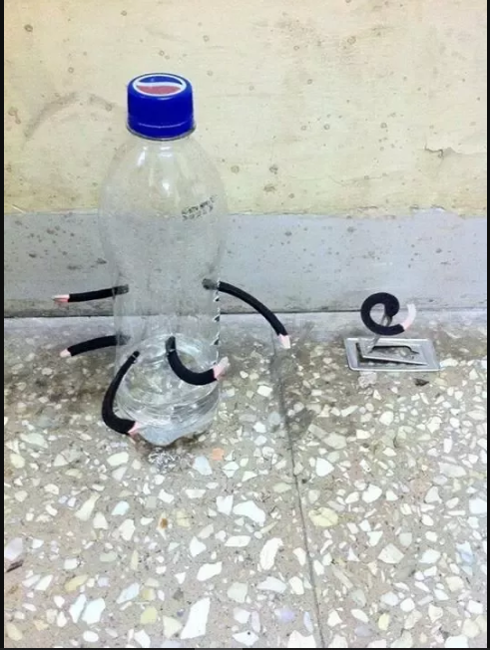

Bottles, traditionally used for containing beverages, have ingeniously transformed into a "jugaad" solution for holding mosquito coils, showcasing practicality and inventive repurposing to enhance mosquito protection.

1. **Using used Glass Bottles For Home Décor :-**

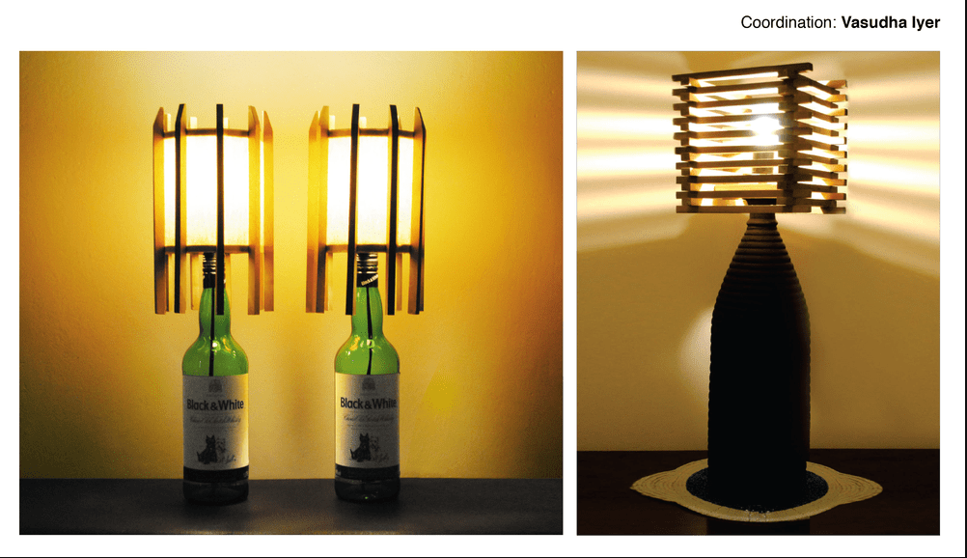

Glass bottles, typically used for containing liquids, have been ingeniously repurposed as a "jugaad" solution for creative home decor, showcasing resourcefulness and inventive upcycling to add aesthetic charm and uniqueness to living spaces.

1. **Using ToothPaste as a Solution for broken Taps:-**

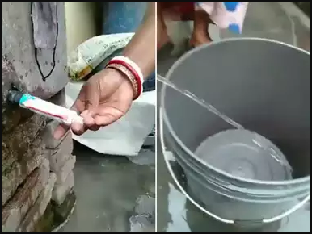

Utilizing toothpaste as an inventive "jugaad" fix for a broken tap demonstrates resourcefulness by temporarily sealing leaks, offering a quick and accessible solution until proper repairs can be undertaken.

1. **Using Shoe for Holding Mobile Phones on Charging :-**

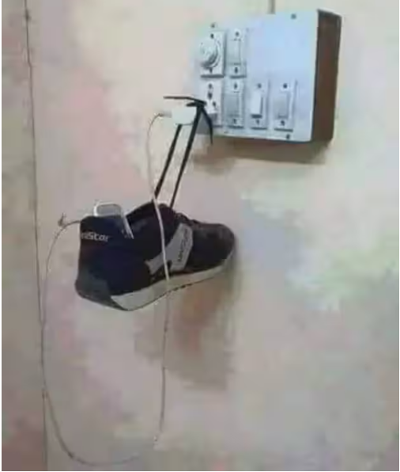

Employing a shoe as a clever "jugaad" hack to support a charging mobile phone showcases practical ingenuity, providing a makeshift stand for hands-free usage while repurposing everyday items creatively.